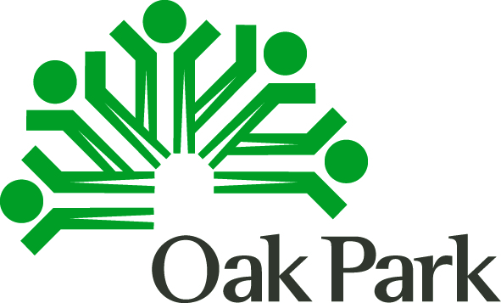 Date: Thursday, March 14, 2019
Time: 7:00 pm
Location: Village Hall 215

Title: Community Development Citizens Advisory Committee, PY 2019 Grants Proposal Recommendation Process
Introductory Meeting
Agenda
Topic | Notes
- Welcome and Introductions

- Review & Approval of Meeting Agenda;
Non-Agenda Public Comment
- Approval of Last Meeting’s Minutes (September 6, 2018)
- PY 2019 Application Process Overview
- Applications
- Attachments
- Presentations and the two other meetings
- Potential Scoring Worksheets

- Site Visits
- Applicant Site Visits, 3/21/19

- New/Other Business
- Adjourn

Get the latest Village news via e-mail. Just go to www.oak-park.us and click on the e-news icon to sign up. Also, follow us on facebook, twitter and YouTube.
If you require assistance to participate in any Village program or activity, contact the ADA Coordinator at 708.358-5430 or e-mail adacoordinator@oak-park.us at least 48 hours before the scheduled activity.

