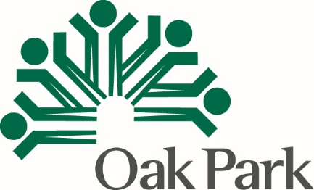 PY 2021 Timeline, CDBG Public Services
As with all application components, please carefully read the Instructions
Organization
Project Name

Timeframe | Activity | Person Responsible
Month 1
Month 2
Month 3
Month 4
Month 5
Month 6
Month 7
Month 8
Month 9
Month 10
Month 11
Month 12

