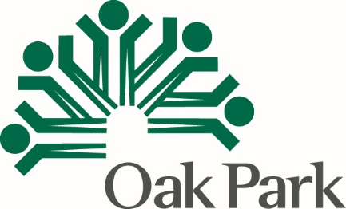 PY 2021
CDBG Public Facilities & Improvements
Organization Name
Proposed Project Name

As with all application components, please carefully read the Instructions

Beneficiary Component | Number or Percent
Total of all Persons Benefiting, without regard to income or residency

Number of all Very Low, Low and Moderate-Income (LMI) Persons to be served
Percentage of LMI benefit (above total persons x 100)
Number of all Oak Park persons benefiting
Percentage of Oak Park persons benefiting (#Oak Park persons benefiting total persons benefiting x 100)
Number of Very Low, Low and Moderate-Income (LMI) Oak Park Persons to be served
Percentage of Oak Park persons that are LMI (#LMI Oak Park persons benefiting total Oak Park persons benefiting x 100)

