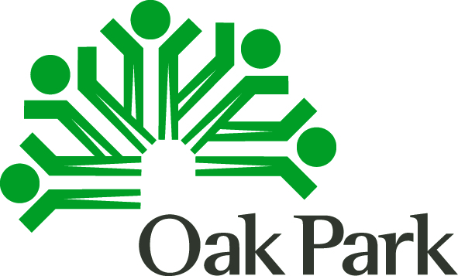 PY 2018 CDBG Public Services
As with all application components, please carefully read the Instructions
Organization
Project Name

Goal Statement:
Inputs | Outputs |  | Outcomes |  | Measurement/Indicator for Short Term Outcomes
 | Activities | Participation | Short Term | Intermediate/Long Term
X Total unduplicated persons served (without regard to income or residency)
X Extremely Low, Low and Mod-Income Persons served
X Oak Park persons served
X Extremely Low, Low and Mod-Income Oak Park Persons Served

